FINAL CAPSTONE PROJECT

- url: https://github.com/Abhiramikannan/Azure-Final-Capstone-Project.git
- Created organisation
- Created project
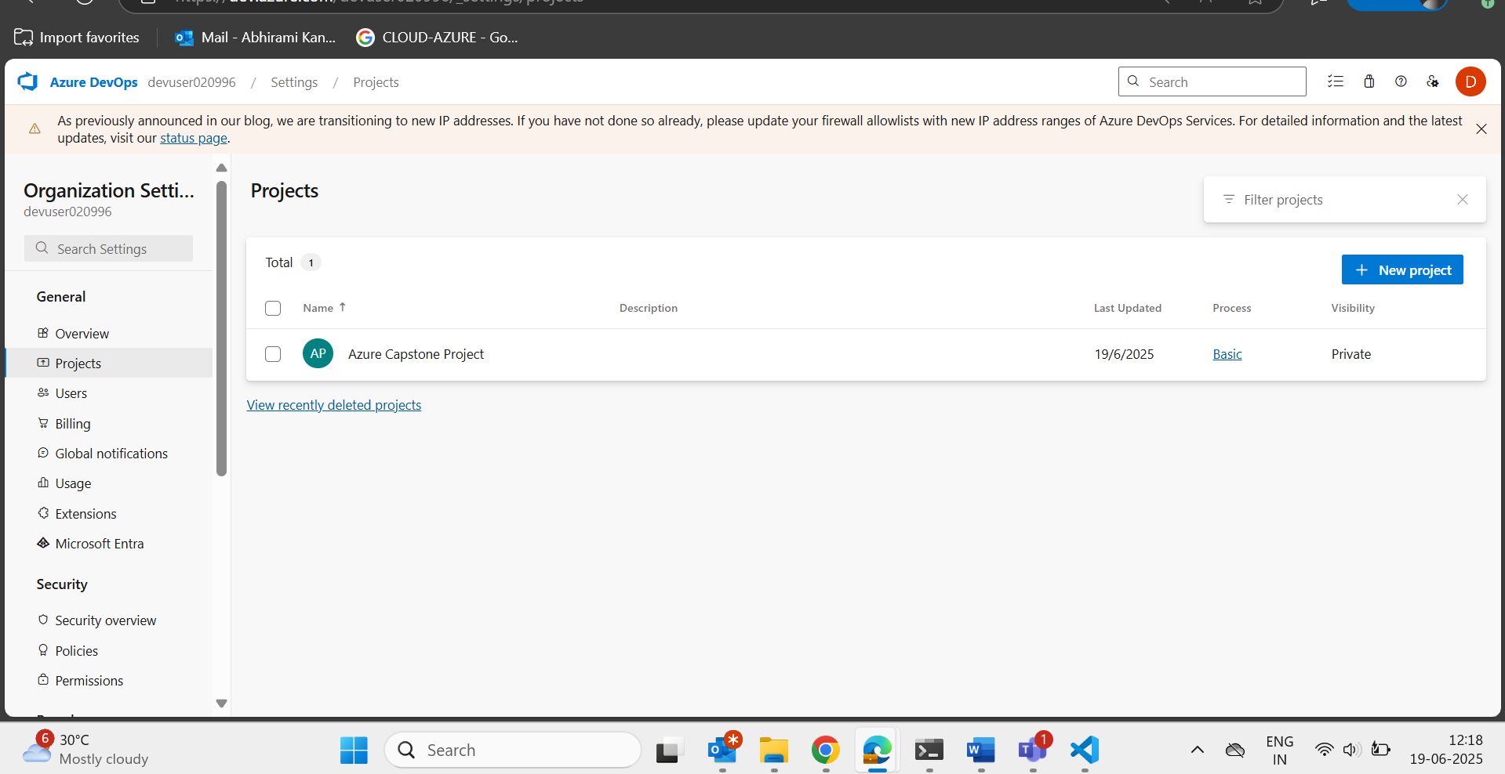

- Included terraform infrastructure code in github.
- Created vm and installed the terraform and confirmed the infrastructure is working properly/not.
  - For this installed az using command:
    - curl -sL https://aka.ms/InstallAzureCLIDeb | sudo bash
    - az login
- pushed the code into github (issue faced -secrets)
  - git reset 5281c8f
  - cat .gitignore
  - git add .
  - git commit -m "terraform infra"
  - 812 git push origin main
- Cat .gitignore:

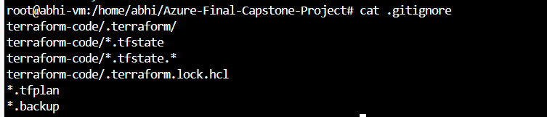

- Azure devops:
  - Created agent pool
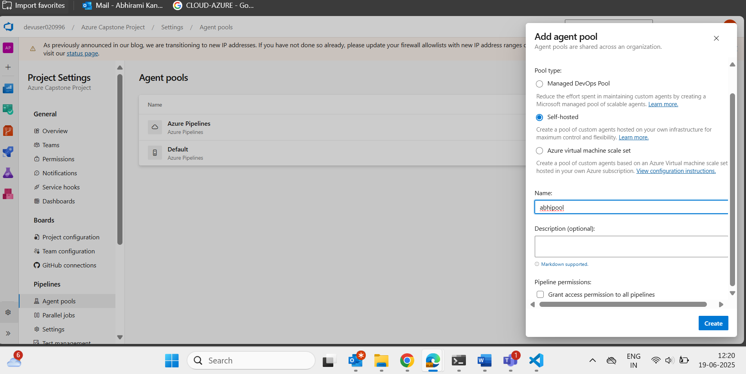
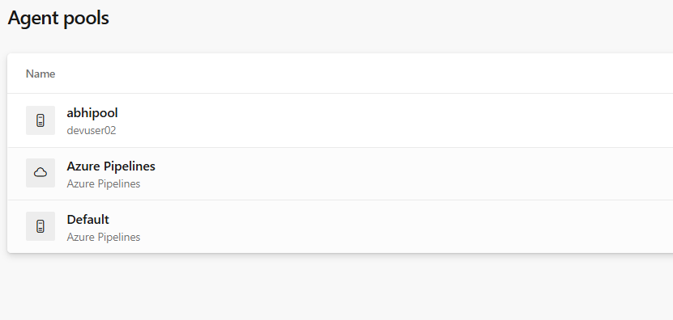
- Adding an agent :
abhipool->add agent
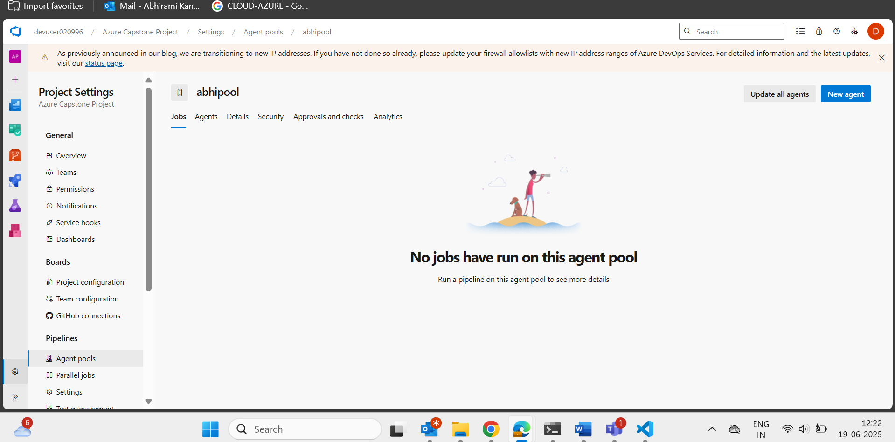
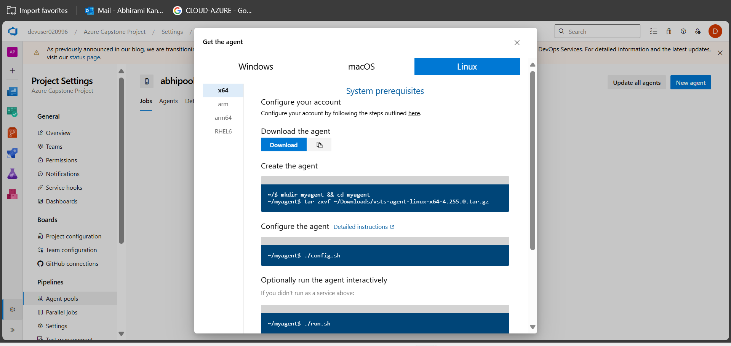

- Execute these commands on ur virtual machine and active the agent
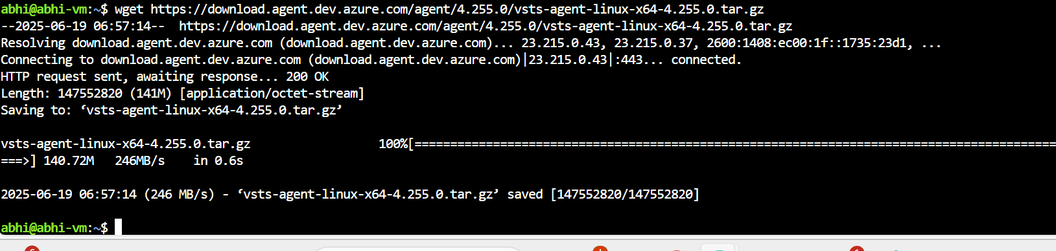

- Created the agent using commands:
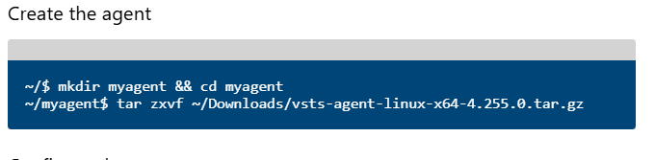

Changed the location tar zxvf ~/Downloads/vsts-agent….to
tar zxvf ../vsts-agent-linux…………
- Because my file is in that location not in Downloads folder

- Executed the commad: ./config.sh

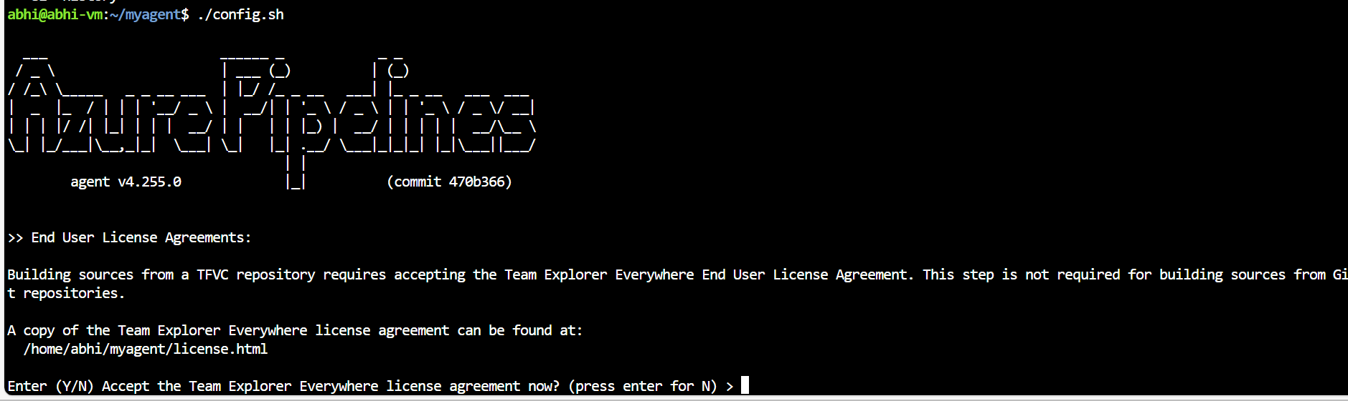

Azure devops->user settings->pat->full access->copy pat

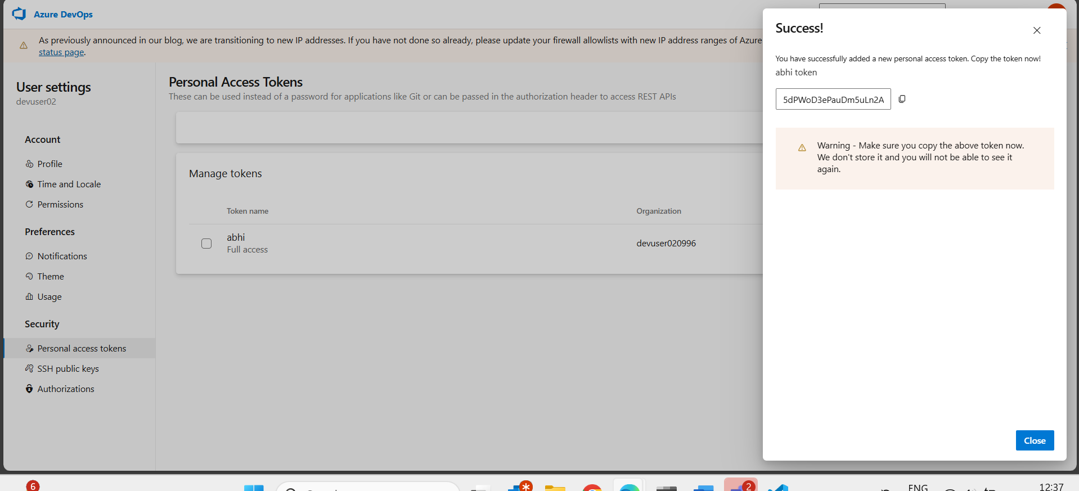

Server url is: our url in the browser
https://dev.azure.com/devuser020996/

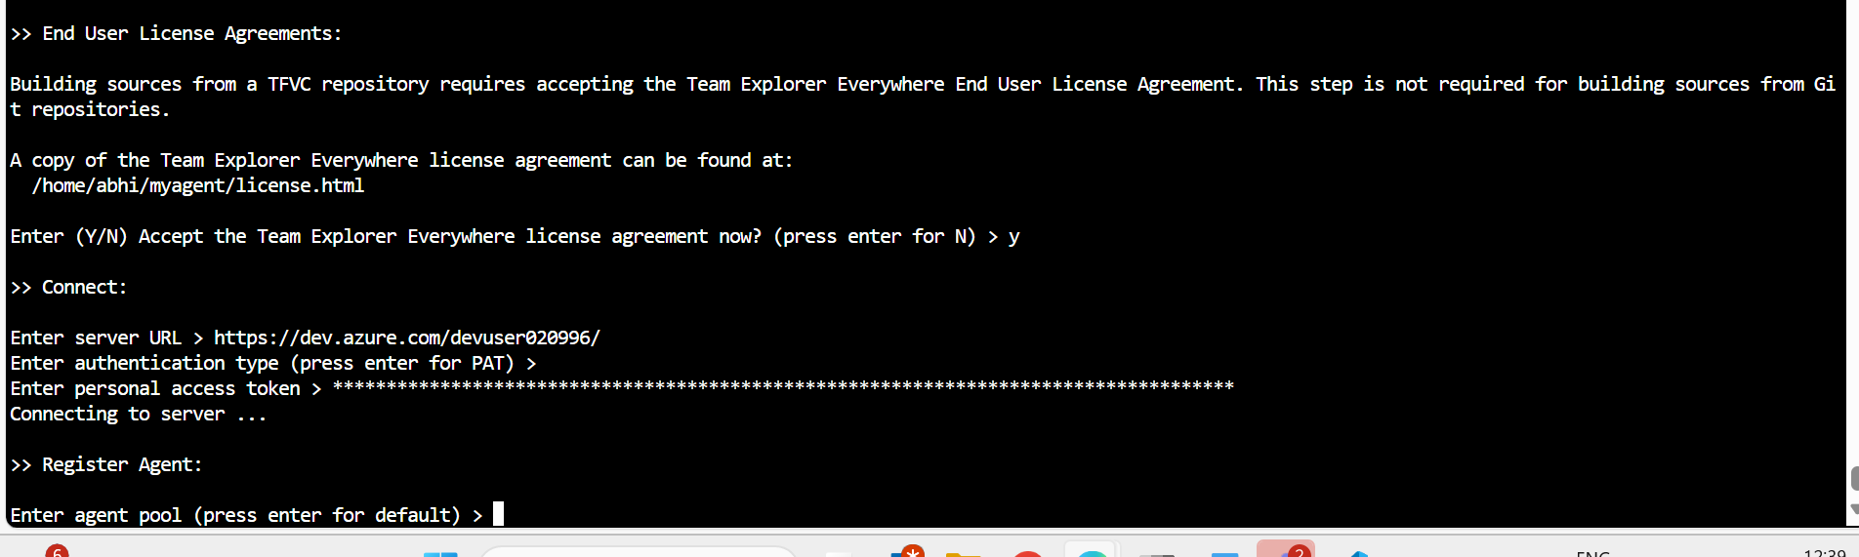

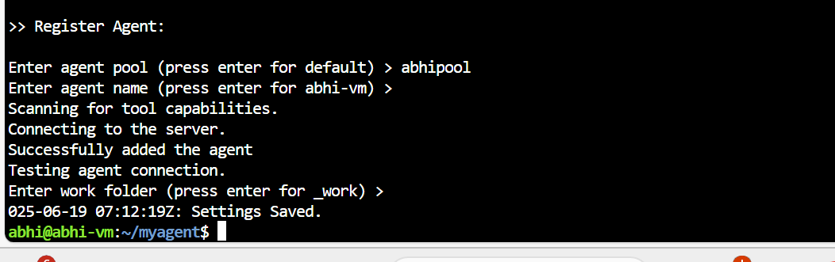

- To run the agent:


- Importing my repository:
Repo->files->import
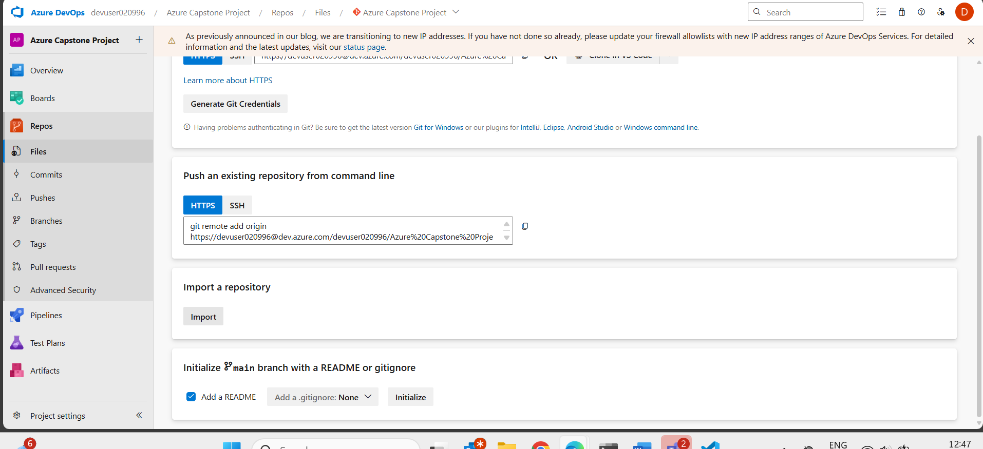

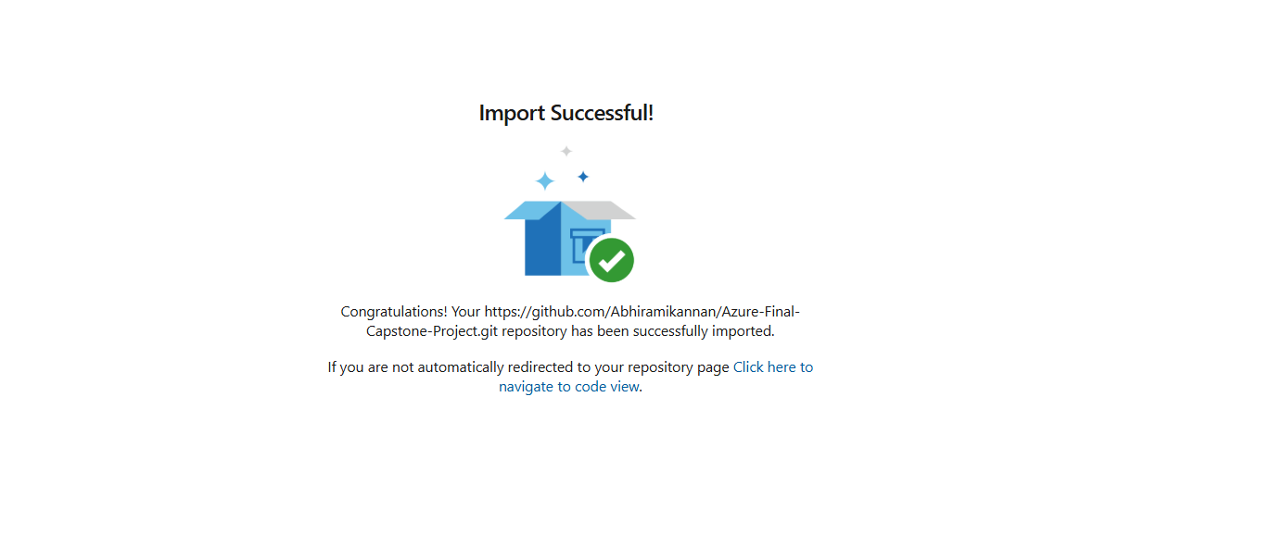
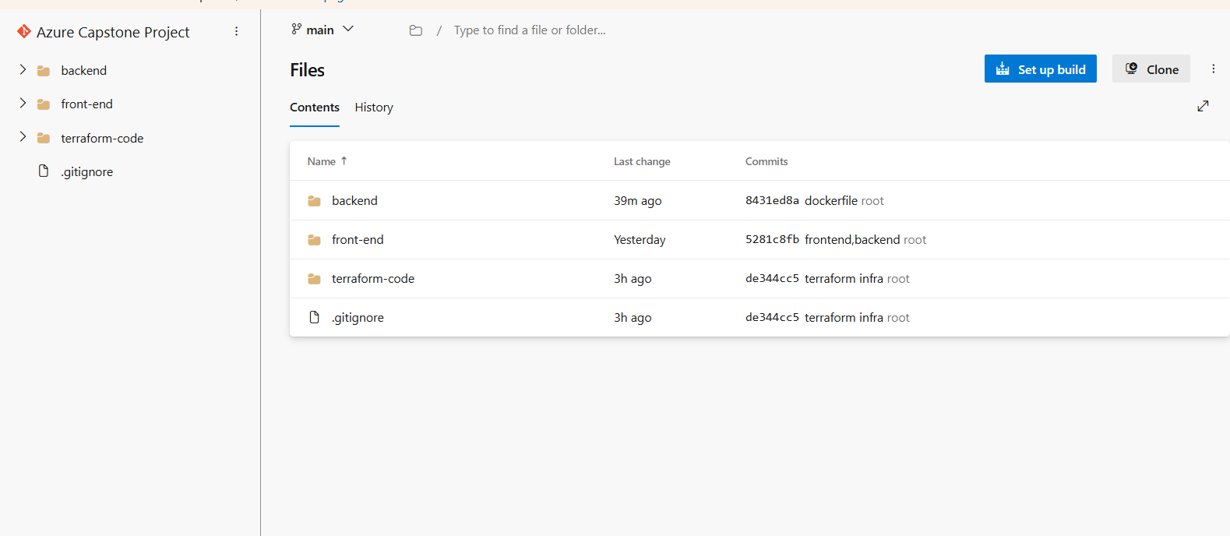

- Creating pipeline:
New pipeline:
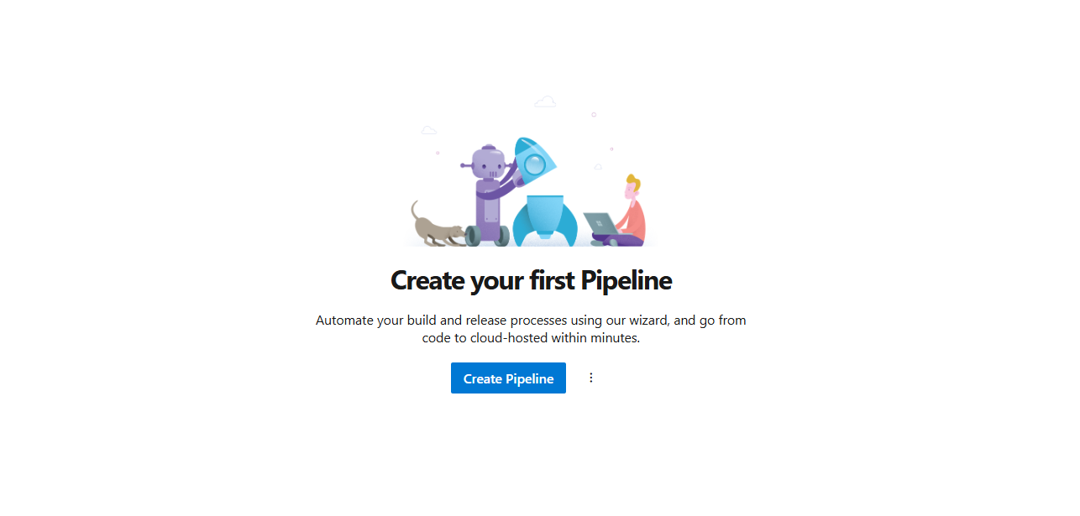
- Click azure repos git

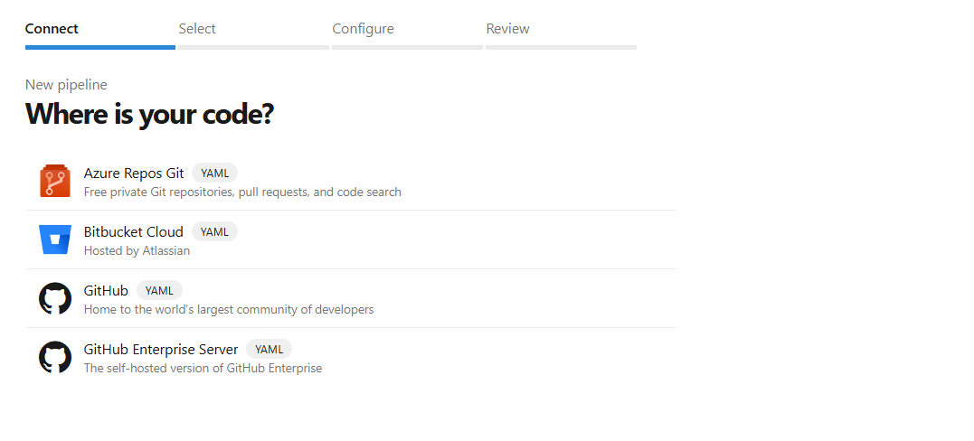

- Click capstone project
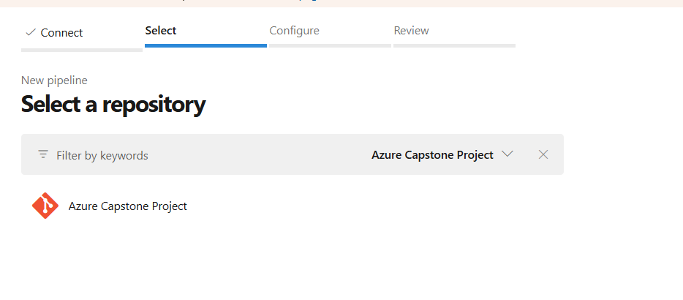

- Click -deploy to azure Kubernetes service
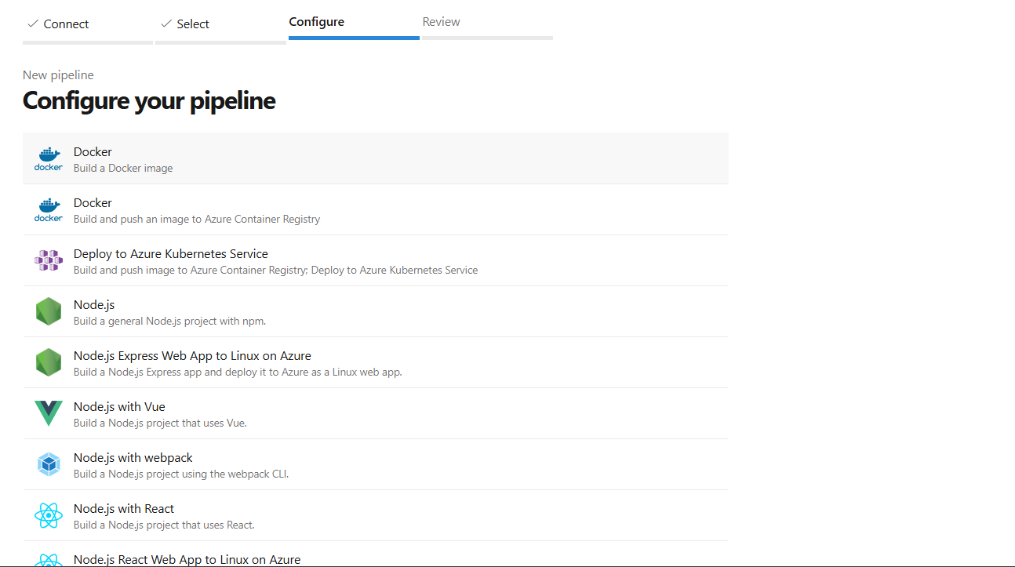

- Select ur subscription:
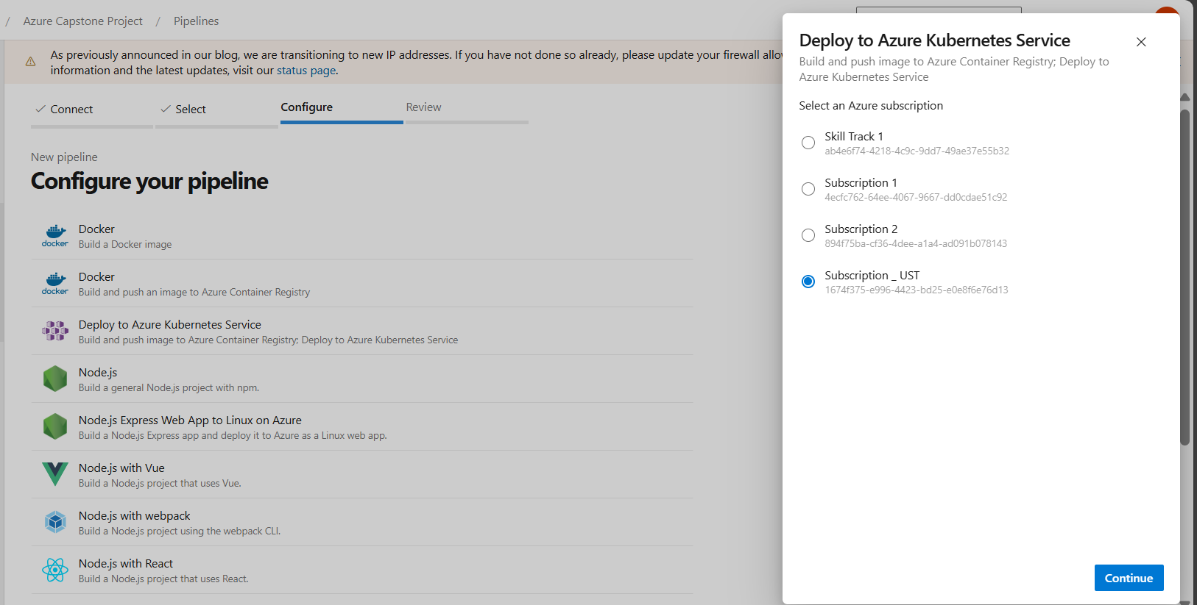

- Changed service port to my eureka service port in dockerfile
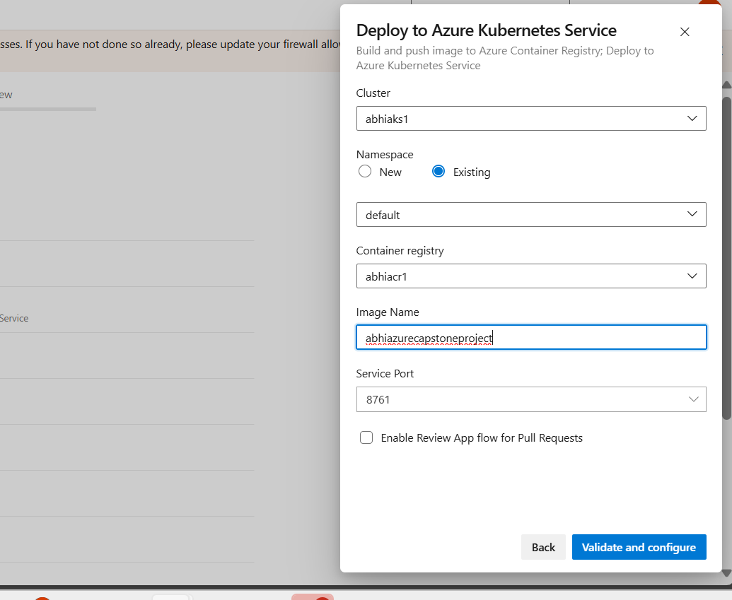
- Validate and configure

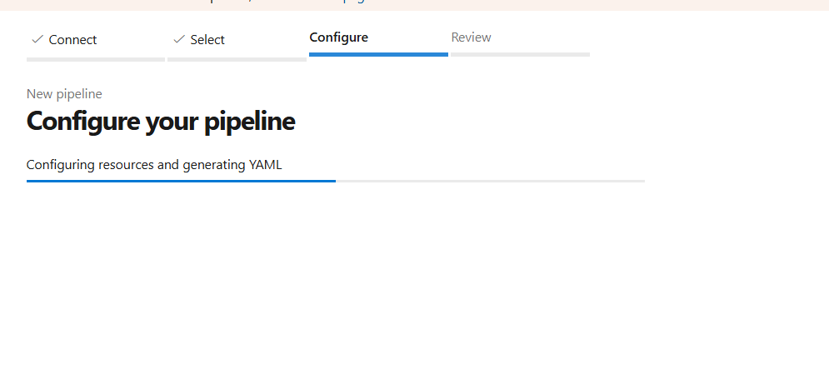

- Review page;

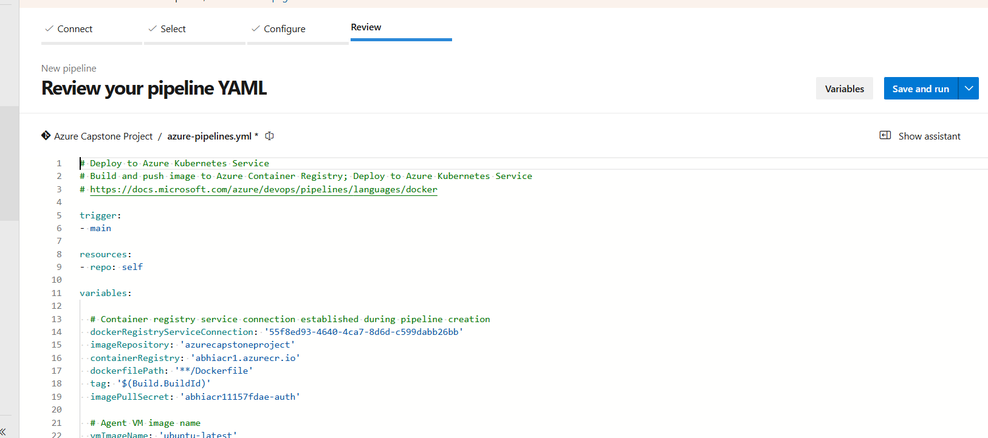

- Duplicated the tab and again created the cluster2 -same method
and copied the deploy code of cluster2 and pasted in the code which shown above(environment of both clusters should be different-ensure it)
- Also add name: ‘abhipool’ in wherever pool is mentioned

- Also change vmimagename as abhi-vm (as I configured while creating the agent)
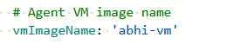

Grand all permissions for agent while creating-else-error
Resolved : agentpool->security-> no permissions->+ (gave permissions to that project)

- Docker permissions: take abhi-vm -> sudo usermod -aG docker abhi and restart cloud shell and start the agent

- Else error:
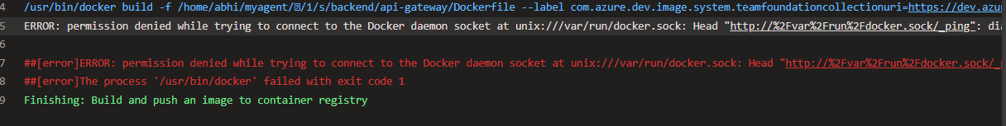
- Search maven and added the script
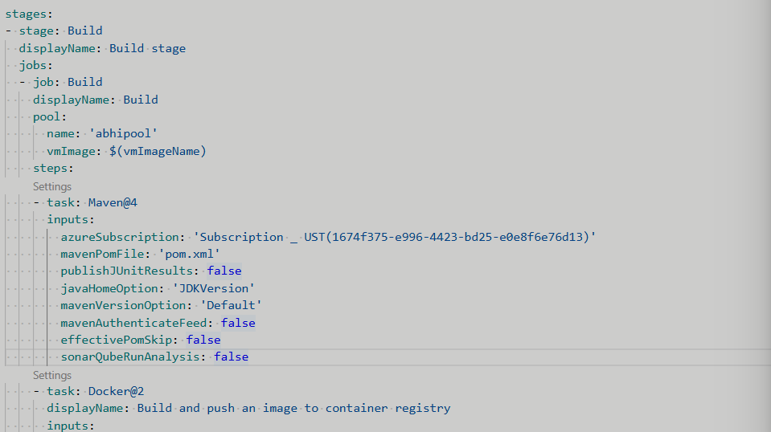

- Instead of that we can also create a service connection(for each cluster =each service connection) for both clusters and mention the service connection id for each cluster in the pipeline.
- Creating diff repo for each microservice
Create repo ->user-service
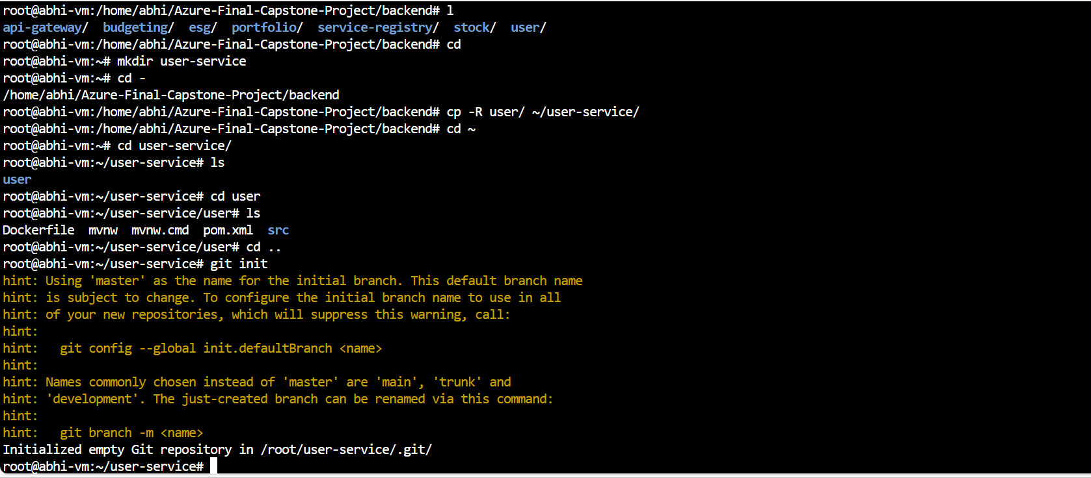
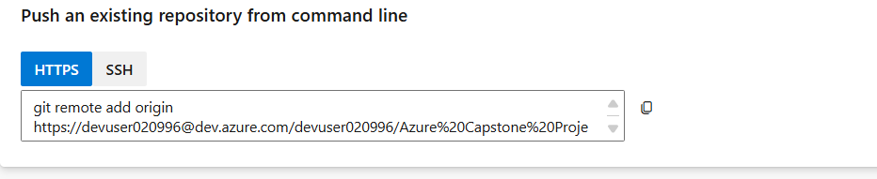
Generate git credentials and copy and paste in vm
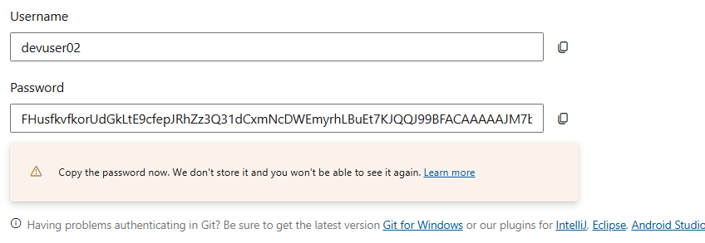

- If I want to delete the repo
  - Project settings-> repo -> select repo -> delete
- Going to create database before creating pipeline -> local testing
  - Because: if database didn’t work,means didn’t accessible and cant store and retrieve data -> application deployments wont work
  - Soo select database like this because I used mongodb -> search mongodb
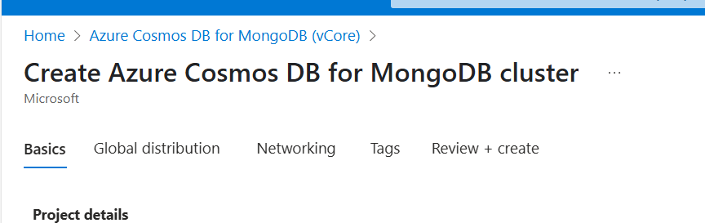
  - Configure the cluster tier
  - And give the rule for vnet1 and vnet2 ..we need to give rules for the subnets range ..but if we give vnet rule it will include subnets coming under that vnet also…
  - Soo vnet1 address range is:

  - Soo it will be of range 10.10.0.0 to 10.10.255.255
  - If 10.10.0.0/24 then range will be 10.0.0.0 to 10.10.0.255 (for my reference) =2^8 [32-24=8]
  - Like that give the rule for vnet2 also
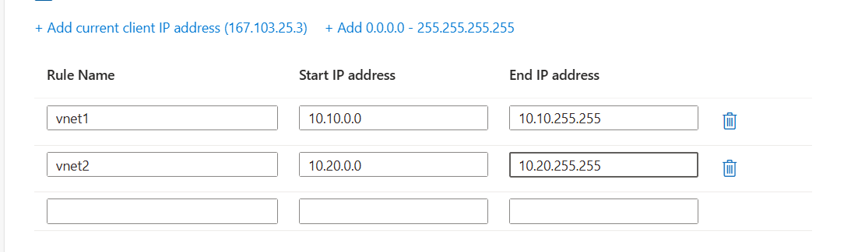

  - Created the db and in the resource ->settings->connection string I got
  - So in the application.properties of user service I just pasted the string by uncommenting 2 nd line
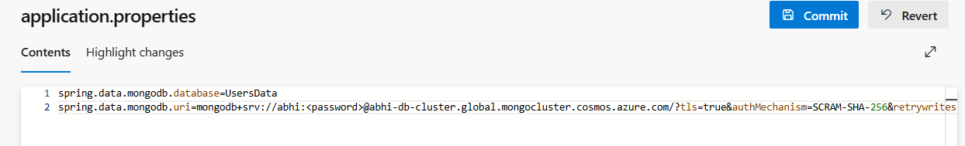

  - Check by running pipeline and the pod is coming up/not?

- Create a pipeline for user-service (user microservice is communicating with database)=so no need to make eureka service and all up..if we are checking for 1 service
- So in terminal checked by giving credential of cluster1
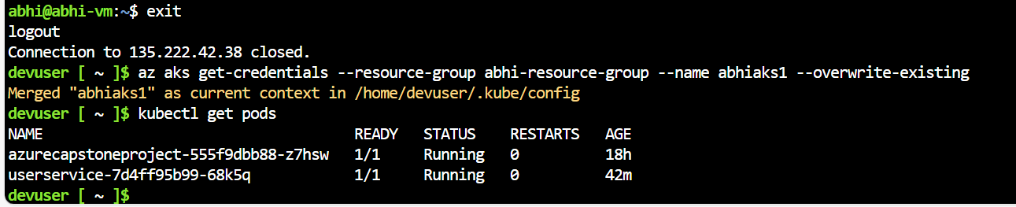
  - Here pods are working(pods created by the deployment file)
  - So this means user service can communicate with mongodb database
  - Also check logs of pod using command: kubectl logs podname
  - Error->connection refused->so need to up the eureka service
Error:
  - Kubectl get svc…user service have load balancer make it clusterip
  - So change the manifest path in ur pipeline instead of
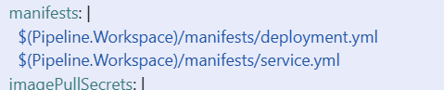

Change to:
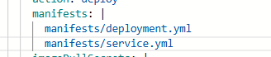
so it will create the files in ur repo folder and u can edit acc to ur requirements and it will not create in _work folder in myagent and change the type of service as clusterIp …
because front end only exposed to public not backend.
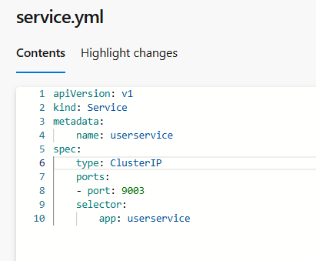
- Create the service for eureka-serice ie, service-registry and it should be load balancer and copy the load balancers external ip in application properties instead of localhost :
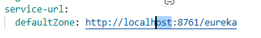
- Created pipeline for service-registry -LoadBalancer
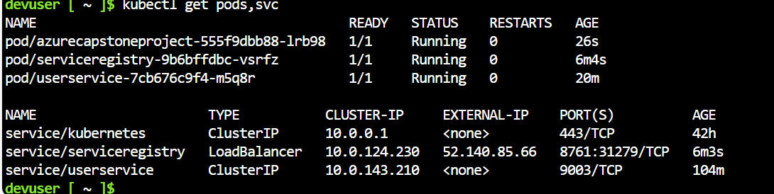

- Copy the load balancer external ip to application.yml of every microsevices
- User-service:
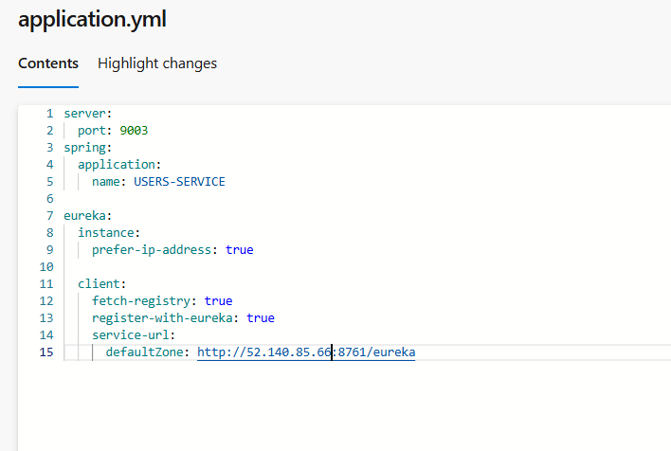
- I tried to take logs of user service again but still got error
- Deploy the user-service again->then only it will know
- Change and deploy and see logs(every microservice)
- so again I checked the pods and logs of user-service
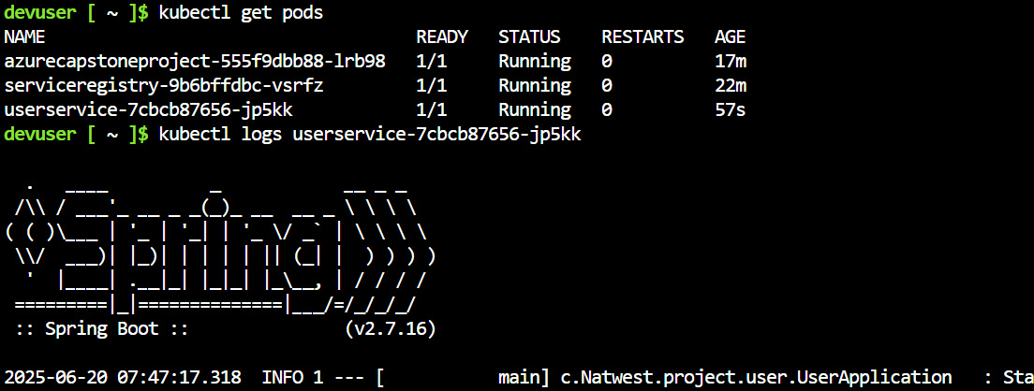
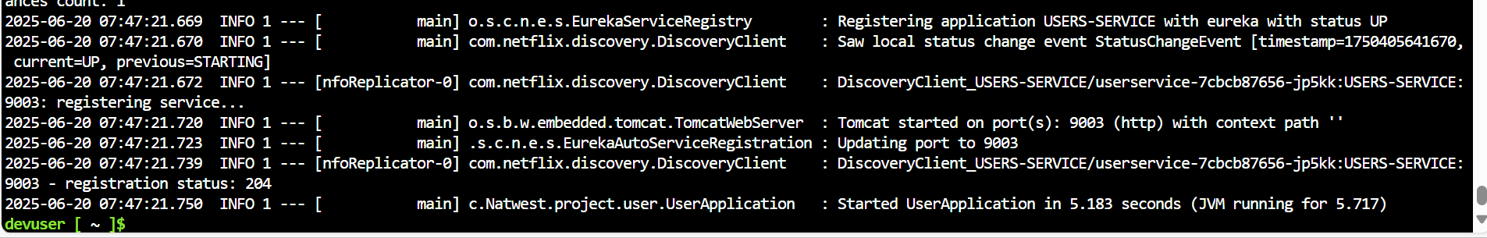
- worked.
- Another microservice: stock
  - Updated application.properties with connection string of mongodb

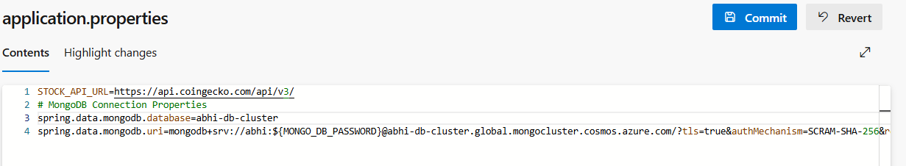
  - Build pipeline and again copy the service-registry external ip to this microservice application.yml and again run the pipeline …
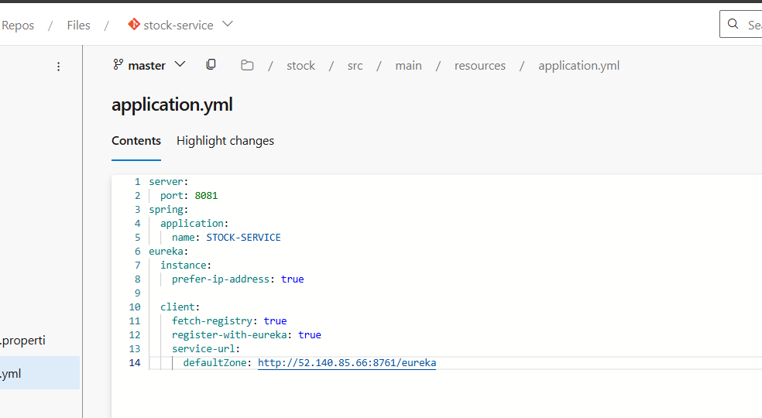

  - Same
- So we need to configure the credentials of database into key vault and give the variable of the credentials in application.properties and add the external ip of service-registry in application.yaml file then try to see the backend services can talk to database
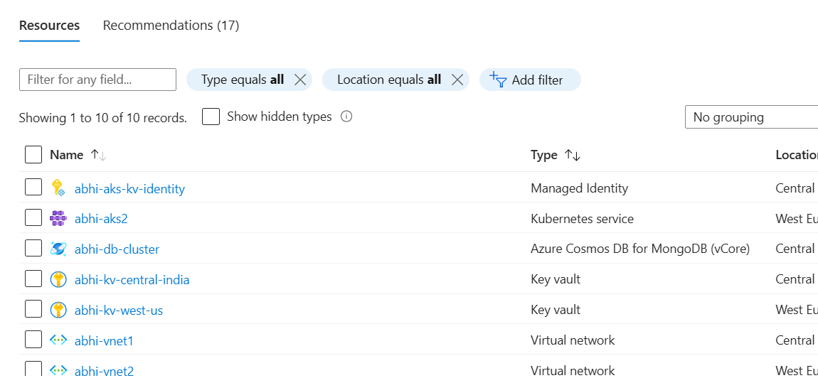
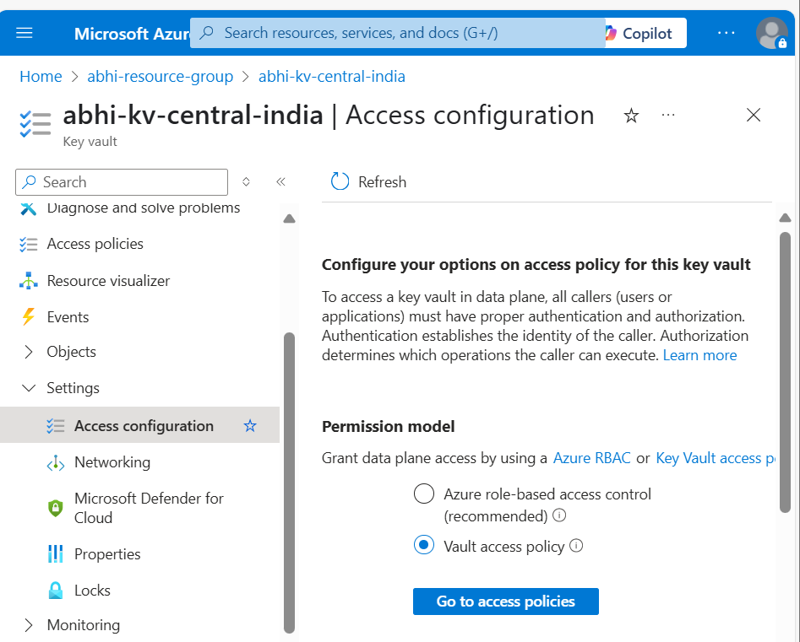
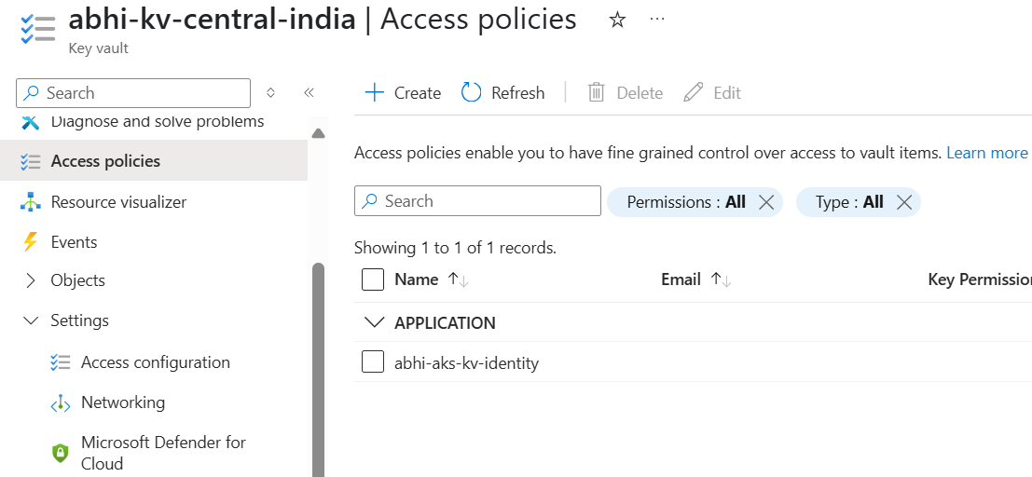

- Didn’t worked so I created using terraform code itself
- Check terraform code

- abhi-aks-kv-identity : which only lets you look at secrets inside the Key Vault.
Okay, think of it like this:
The "old thing" (your abhi-aks-kv-identity identity) is like a special key that only lets you look at secrets inside the Key Vault.
It does not have a key that lets it:
- Build new things like entire AKS clusters, networks, or the Key Vaults themselves.
- Put new secrets into the Key Vault, or change/delete existing ones.
Your pipeline needs a "master key" (the new Service Principal) that can do all of those things – build, change, and manage everything.

Now I want to create a new service principle because the old one in the code doesnot have the power to do anything like above mentioned so require service principal

- Command:
  - az ad sp create-for-rbac --name "abhi-pipeline-sp" --role "Contributor" --scopes "/subscriptions/1674f375-e996-4423-bd25-e0e8f6e76d13" –json
- Get the Service Principal's Object ID (Required for Key Vault Access Policy in Terraform)
  - az ad sp show --id "df6ba479-db72-463c-bef0-59a76e3b6bf4"
  - df6ba479-db72-463c-bef0-59a76e3b6bf4 this is clientid
  - this command: shows object id: "id": "1c6ad34d-73d1-4c1a-b38d-735be951325d"

- replaced the objected
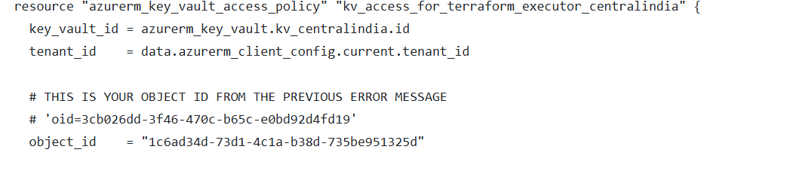
- Get the Resource ID of your Storage Account
- Command:
  - STORAGE_ACCOUNT_ID=$(az storage account show --name abhicapstonestorage --resource-group abhi-resource-group --query id --output tsv)

  - Grant the "Storage Blob Data Contributor" Role to your Service Principal

    - assign the role that allows your Service Principal to read and write blobs (your Terraform state file) in that storage account.

Command:
az role assignment create \
--role "Storage Blob Data Contributor" \
--assignee "df6ba479-db72-463c-bef0-59a76e3b6bf4" \
--scope "$STORAGE_ACCOUNT_ID"
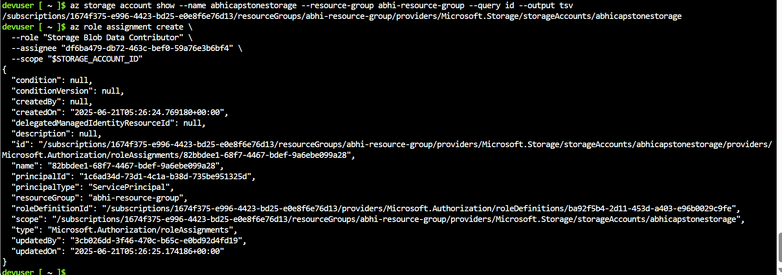
- Run these two commands sequentially in your terminal on the VM. After they complete, your Service Principal will have the necessary permissions on your Terraform state storage account.
- Do terraform apply in ur vm
- Create service connection for the service principal u explicitly created:
  - Selected manual and secret

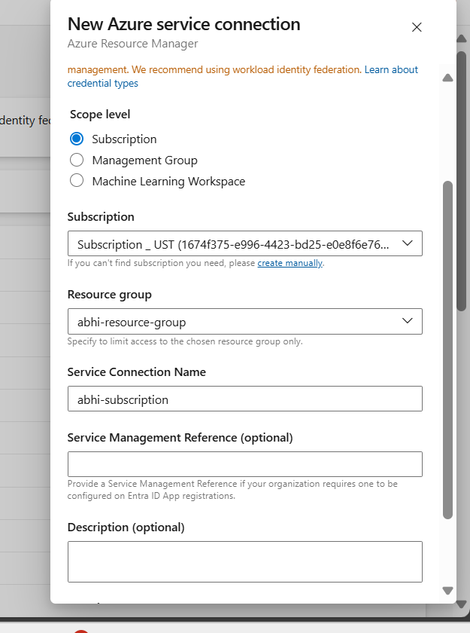
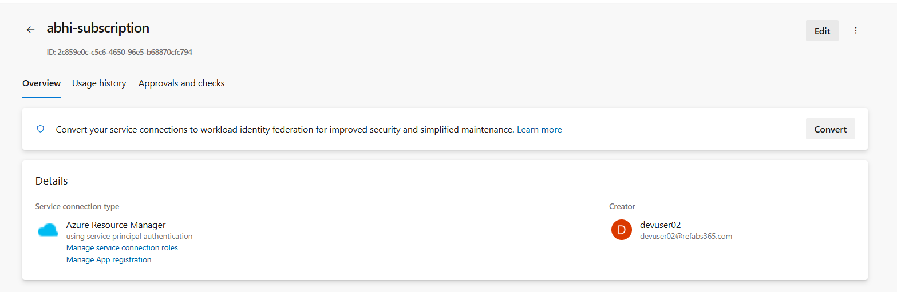

- Created the role assignement to azure key vault central india ->key vault secret user
- And added the user
- Not worked
- I gone through the vault in each region and added the user and gave the secret management permissions and worked
- Pipeline:
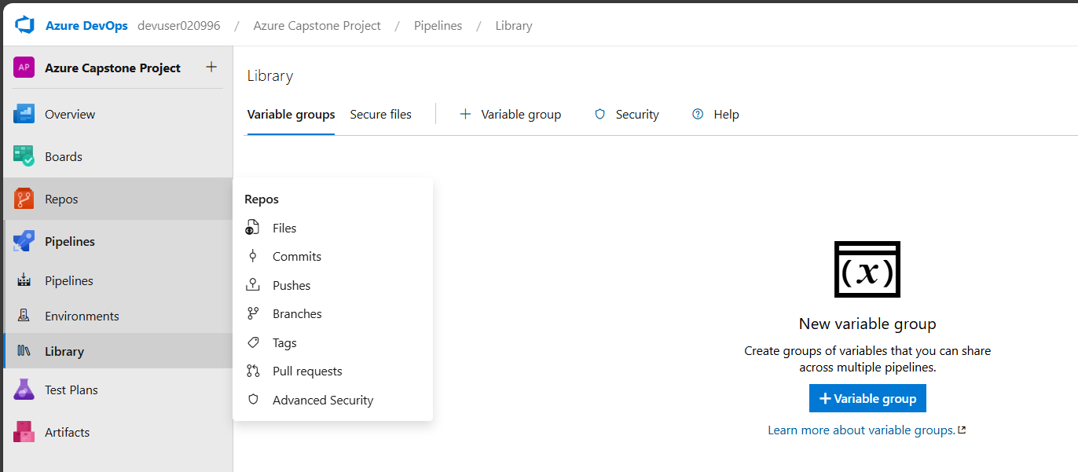
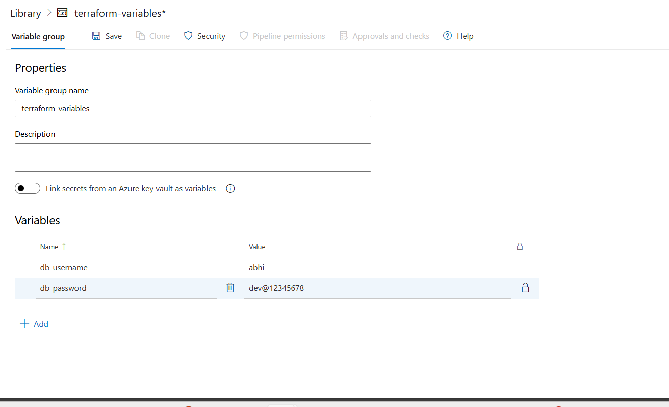

- Lock and Save it
- Do pipeline for infra
- And parallelism error causing due to agentpool not find
- https://learn.microsoft.com/en-us/azure/aks/csi-secrets-store-driver

- Install CSI drivers to fetch the data from key vault to give on deployment.yml
- Not needed edited the code in terraform by giving a dependency inside cluster ..

